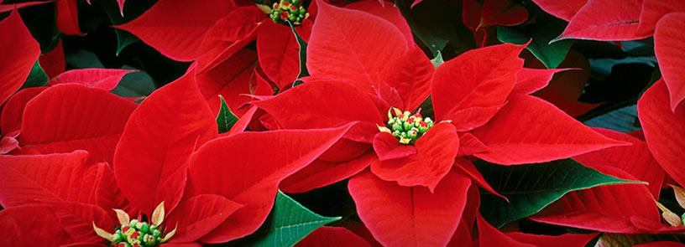

A special fundraiser to benefit
Enter organization name here

Get a headstart on your holiday decorating with gorgeous, locally-grown poinsettias direct from Headstart Nursery’s greenhouses!

These beautiful, vibrant poinsettias are the easiest way to get your home or business ready for the holiday season. They also make wonderful gifts.

All poinsettias are a deep red color, grown in 6½” pots with festive red pot covers. Plants are available individually or in cases of 6 plants. All poinsettias are sleeved for protection during shipment.

Fundraiser price: | $ per plant or  $ per case of 6 plants
Order forms due: | Enter order form due date here
Pick up plants: | Enter pickup date  Enter pickup time(s)  Enter pickup location

