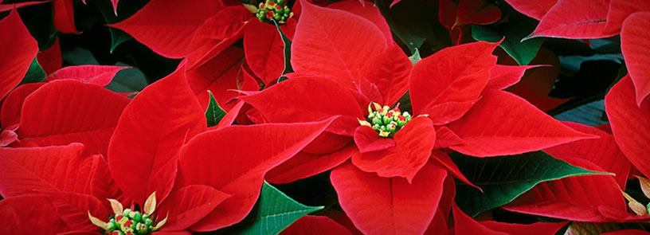

Special fundraiser to benefit
Enter organization name here

Get a headstart on your holiday decorating with gorgeous poinsettias direct from Headstart Nursery’s greenhouses! These beautiful, vibrant poinsettias are the easiest way to get your home or business ready for the holiday season. They also make wonderful gifts.

Plants are available for a just $ per plant or a special discounted rate of $ per case of 6 plants. All proceeds benefit Enter organization name here.

Poinsettias are a deep red color. Plants are grown in 6½” pots with festive red pot covers and are sleeved for protection during shipment.

Please plan to pick up poinsettias on Enter pickup date, time, and location here.

 ----------------------------------------------------------------------------------------------------

Student Name: _____________________________________________

Teacher: _____________________________________________

Phone #: _____________________________________________

 | # of Cases  (6 Plants per Case) | x $ =
 | # of Individual Plants | x $ =
TOTAL DUE

Please make checks payable to Enter organization name here.
Order forms must be turned in by Enter order form due date here.

